1.0 The comprehensive performance of lithium battery is better than other common batteries

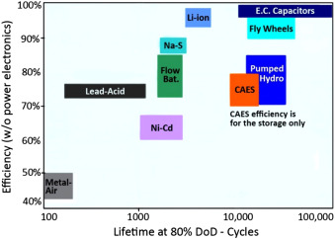

Fig. 3. Comparison of different types of ESSs in terms of cycle life and efficiency [[9]](https://www.sciencedirect.com/science/article/pii/S1364032119300334#bib9).

Reference：026

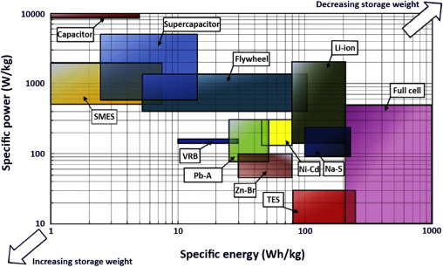

Fig. 4. Comparison of different types of ESSs in terms of specific energy and [specific power](https://www.sciencedirect.com/topics/engineering/specific-power) [[18]](https://www.sciencedirect.com/science/article/pii/S1364032119300334#bib18).

Reference：026

2.0 Lithium battery is the most popular type of battery

Provision and consumption of electricity occur simultaneously [[9]](https://www.sciencedirect.com/science/article/pii/S1364032119300334#bib9), [[67]](https://www.sciencedirect.com/science/article/pii/S1364032119300334#bib67), so the quantity generated must meet a varying demand. ESSs help balance supply and demand [[68]](https://www.sciencedirect.com/science/article/pii/S1364032119300334#bib68) through short- to long-term [storage duration](https://www.sciencedirect.com/topics/engineering/storage-duration) periods, while aiding in frequency and voltage control at local and large grid scales. [Electrical energy](https://www.sciencedirect.com/topics/engineering/electrical-energy) must be converted into another form to be stored [[69]](https://www.sciencedirect.com/science/article/pii/S1364032119300334#bib69), and batteries are an obvious storage option. Batteries will certainly play an important role in integration of intermittent renewable sources (wind, solar), as they smooth output and enhance [renewable energy](https://www.sciencedirect.com/topics/engineering/renewable-energy) versatility in micro-generation systems, allowing them to supply and distribute steady electrical power [[70]](https://www.sciencedirect.com/science/article/pii/S1364032119300334#bib70), [[71]](https://www.sciencedirect.com/science/article/pii/S1364032119300334#bib71), [[72]](https://www.sciencedirect.com/science/article/pii/S1364032119300334#bib72). Leaving cost and environmental impact aside, BES is perhaps the most efficient method to stabilize power grids that access important quantities of renewable energy (e.g., >10%) [[21]](https://www.sciencedirect.com/science/article/pii/S1364032119300334#bib21). Among different types with a share of the BES market, Li-ion is the most prominent with a 55% [market share](https://www.sciencedirect.com/topics/engineering/market-share) ([Fig. 5](https://www.sciencedirect.com/science/article/pii/S1364032119300334#f0025)) [[72]](https://www.sciencedirect.com/science/article/pii/S1364032119300334#bib72).

Reference：026

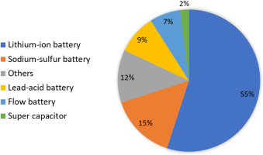

Fig. 5. Worldwide battery [energy storage system](https://www.sciencedirect.com/topics/engineering/energy-storage-system) installed capacity in 2016 [[72]](https://www.sciencedirect.com/science/article/pii/S1364032119300334#bib72).

Reference：026